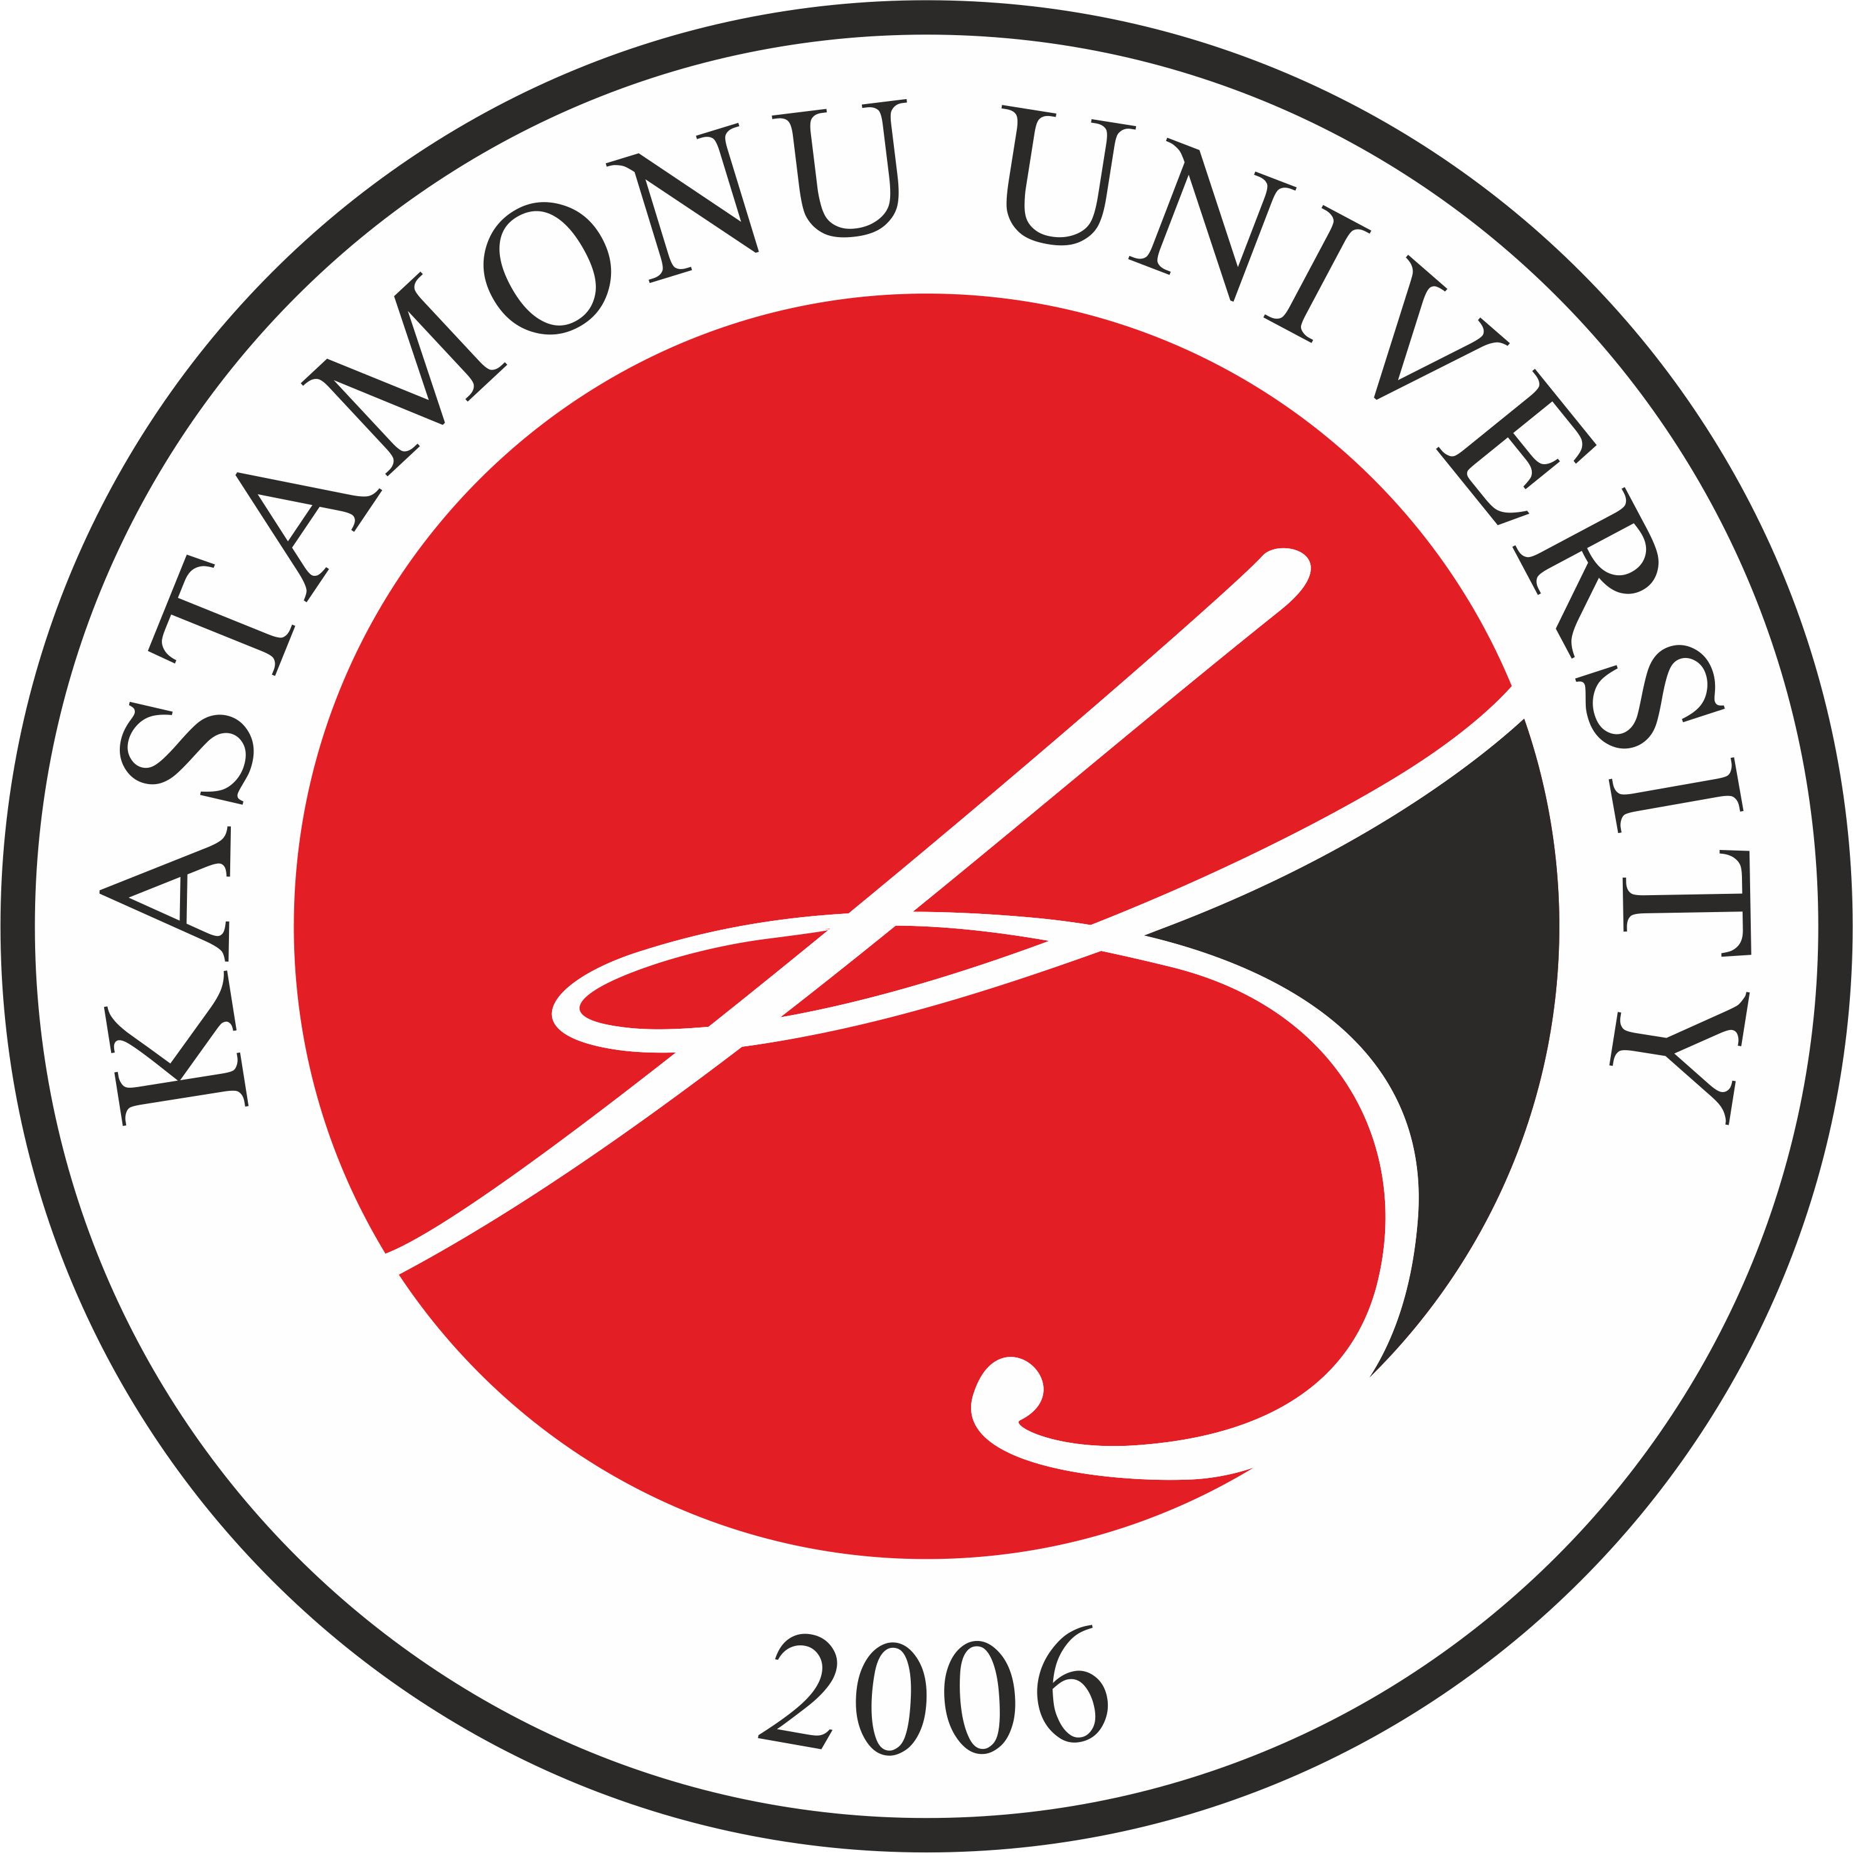

ON
ACADEMIC EXCHANGE AND COOPERATION BETWEEN
Kastamonu University
(Kastamonu, Türkiye)
&
[NAME OF THE UNIVERSITY]
(CITY, COUNTRY)
LOGO
MEMORANDUM OF UNDERSTANDING


Kastamonu University (KU) from Türkiye represented by Rector Prof. Dr. Ahmet Hamdi TOPAL on one part, and, [NAME OF THE UNIVERSITY] (ABBREVIATION) from COUNTRY represented by [NAME OF THE RECTOR/PRESIDENT] on the other part, (both here in after referred to as the Parties collectively, or Party individually), taking into consideration good and strong international relations between KU and (ABBREVIATION), recognizing the necessity and the possibility for developing further perspective bilateral relations between two countries in educational and scientific fields of cooperation, wishing to make their own contribution to development of cooperation between two educational institutions in the abovementioned fields, hereby conclude this Agreement on academic exchange and cooperation with following provisions:

Article 1
Based on the principle of mutual benefit and respect for each other's independence, the Parties will foster:
- Faculty and administrative staff exchange;
- Students exchange at the graduate and undergraduate levels;
- Joint research activities;
- Organization of academic meetings and symposiums;
- Publication of articles, reports, and other scientific materials of the university faculty members, staff members, and students in the periodical publications of the partner university;
- Exchange of academic information, publications, materials, and knowledge;
- Other forms of educational and scientific activities as may be mutually agreed by the two Parties;
- The parties involved, along with the organizations they are associated with, and the academic staff needing services, have the option to seek services from the Technology Transfer Offices and Revolving Fund Enterprises of the institutions that are part of the agreement.
In order to give effect to these forms of cooperation, representatives of individual faculties and institutes within the two Parties will be encouraged to consult each other and to develop specific plans for collaboration in any or all of the ways mentioned above.

Article 2
The implementation of each program based upon this Agreement shall be negotiated and agreed upon by the Parties under a separate agreement prior to the initiation of the particular program. This separate agreement will clearly describe the functions and activities to be developed, work schedule, personal profile, financing, rights and obligations of each Party, as well as the required documents necessary to determine the goals and scope of each program.

Article 3
It is implicit that each and every activity undertaken under this Agreement is approved by the appropriate officials at each institution and falls within each institution's academic and fiscal constraints. The results of the cooperative research, including but not limited to any newly produced intellectual rights, shall be operated earnestly and fairly through due consultation between the Parties.

Article 4
In the process of implementation of the Agreement's provisions, the two universities shall act according to the legislation of their home countries and inter-governmental agreements on cooperation in the fields of education, science, and culture between the KU and (ABBREVIATION).
All cooperative activities in Article 1 above shall be done in compliance with all applicable laws, regulations, and guidelines of the country and university in which the activity is conducted.

Article 5
This Agreement shall be valid for 3 (three) years, effective upon the signature of this document by authorized representatives of both universities and shall remain in force until terminated by either university by notification. The notification for termination of this Agreement shall be made not later than six months prior to the termination date. Regardless of termination, the Parties shall continue to fulfill their obligations hereunder until all participants who have commenced the program have completed the term in session at the time of termination. This Agreement may be modified at any time after due consultation between the Parties.

Article 6
The Agreement is created in English. Two copies of this Agreement shall be made, one to be held by each university, and both shall serve as originals.
Prof. Dr. Ahmet Hamdi TOPAL |  | NAME OF THE RECTOR
Rector |  | Rector
Kastamonu University |  | NAME OF THE UNIVERSITY
Date: |  | Date:
Signature: |  | Signature:
Address: Kastamonu Üniversitesi Rektörlüğü  Kuzeykent Mahallesi Orgeneral Atilla Ateş Paşa Caddesi No:19 Posta Kodu: 37150 Merkez/Kastamonu/TÜRKİYE |  | Address:
e-mail: ozelkalem@kastamonu.edu.tr |  | e-mail:

